ARTICLES WORKSHEET
Name/Surname:
Number:

1. There's ______ problem with the equipment.

a) A
b) An
c) The
d) ---

2. I need ___ egg for this recipe, but we're out.
a) A
b) An
c) ---
d) The
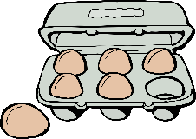
3. I need ___ milk for this recipe, but we're out.
a) A
b) An
c) The
d) ---

4. What's __ longest river in __ world? Is it __ Amazon or __ Nile? I'm terrible at __ geography.
a) the /a/ the/a/a
b) an/--/the/the/a
c) the/the/the/the/--
d) the/the/an/the/--
5. If I were rich, I would buy __ apartment in Manhattan and __ house in Hawaii.
a) the/the
b) a/--
c) an /the
d) an/a

6. He is from __ European country, but I don't know which one
a) An
b) A
c) The
d) ---

7. I enjoyed ___ DVD you gave me for my birthday.

a) The
b) ---
c) An
d) A

8. Is that __ "U" or __ "O"? I can't read it.
a) an / a
b) a/a
c) a/the
d) a/an

9. Judy always says that __ patience is __ virtue, but she is __ least patient person I've ever met
a) a/the/--
b) --/a/the
c) a/an/the
d) --/the/the

10. Every year, __ Smiths go camping in __ Yellowstone National Park. But __ next year, they are going to visit Mr. Smith's mother in __South instead.
a) the/--/--/the
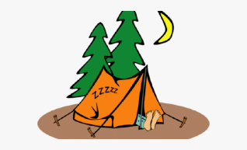
b) --/a/an /the
c) the/an/a/--
d) an/the/the/--

1 | A | B | C | D
2 | A | B | C | D
3 | A | B | C | D
4 | A | B | C | D
5 | A | B | C | D
6 | A | B | C | D
7 | A | B | C | D
8 | A | B | C | D
9 | A | B | C | D
10 | A | B | C | D

